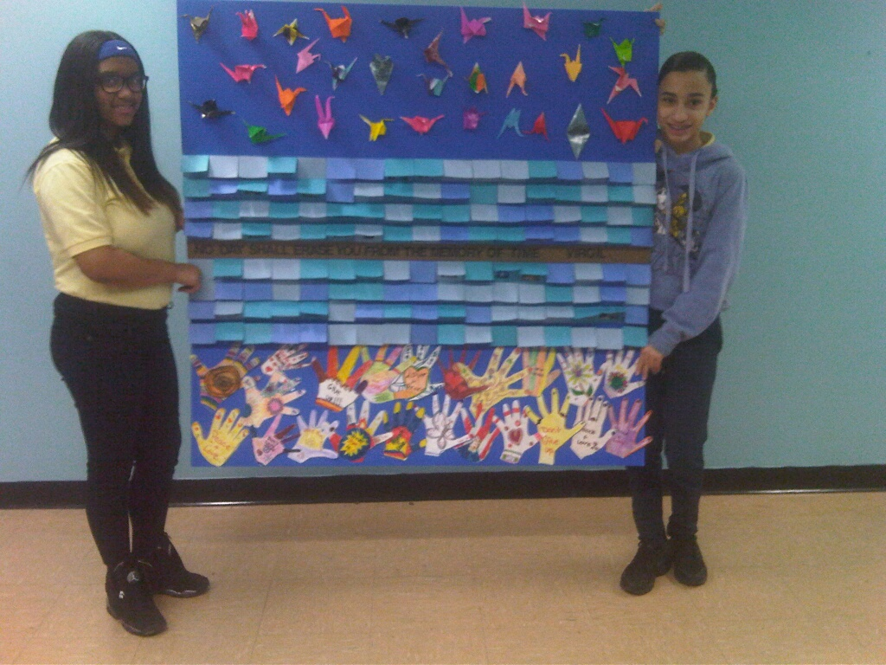

The central panel represents the wall that one sees in the 9/11 Memorial Museum of multi shades of blue panels representing each of the lost lives of that day and the bombing of February 2006. We added our own photo journalism extension by having students each select three pictures of artifacts/exhibits that they saw at the museum, write reflections on the significance of artifact/exhibit and then, paste them onto the inside of the cards.
The hands below represent the hope children have even in the face of the greatest disasters. These hands come from an earlier project that we did on the Tsunami in Japan that happened on March 11 2011. At that time we used the hands to raise money for disaster relief. We saw these hands and learned of the connection of the Japanese tsunami at the 911 Tribute Center. (We had also read aloud in our classroom the book Message on a Wing by ERICCO which memorialized the relationship that grew up between the 9/11 Tribute Center Families Association and the communities in Japan where the tsunami occurred.)
Additionally, at the top of the mural, are paper cranes made using the origami style memorialized in the book Sadako and the Thousand Paper Cranes written by Eleanor Coerr. The short refrain found at the base of Sadako's statue in Hiroshima Peace Park is also included. It reads: "This is our cry, this is our prayer, peace in the world."

